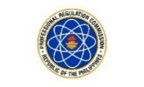
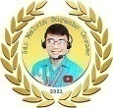
SESSION 4: SIR MELVIN BURACHO REVIEW CENTER (MAY 29, 2026)
GENERAL EDUCATION
(Social Science: Taxation, Politics and Government,
World Civilization and Geography)
https://www.facebook.com/share/v/1CsPQsXkUY/

The space between the tropic of cancer and tropic of Capricorn is called ________.
- Arctic
- Latitude
- Prime Meridian
- Zone

THE EARTH’S GEOGRAPHIC GRID SYSTEM AND CLIMATE ZONES
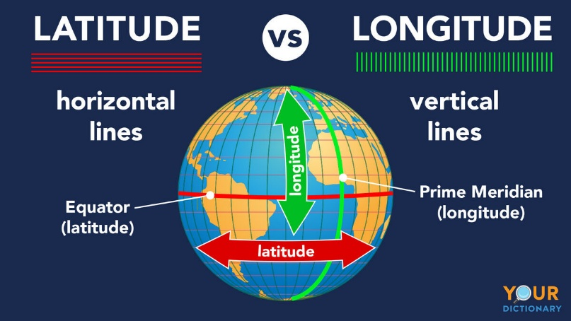
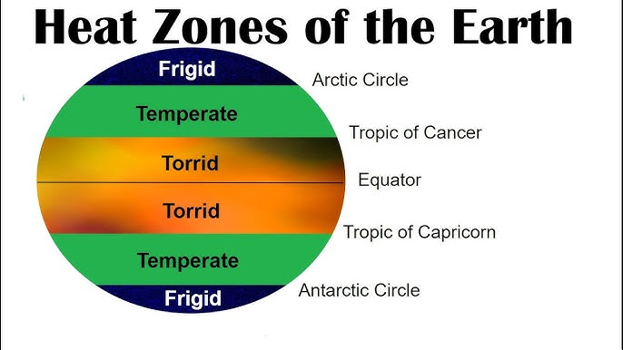

Term / Category | Definition
Oblate Spheroid | Earth's true shape; flattened at the poles and bulging at the equator.
Latitude | Horizontal lines (pahiga); also known as parallels; measures North and South.
Longitude | Vertical lines (patayo); also known as meridians; measures East and West.
Equator | 0° latitude; the primary baseline dividing the Northern and Southern Hemispheres.
North Pole | 90° N; the absolute northernmost point/top of the Earth's axis.
South Pole | 90° S; the absolute southernmost point/bottom of the Earth's axis.
Arctic Circle | 66.5° N; the geographic boundary line for the northern polar region.
Antarctic Circle | 66.5° S; the geographic boundary line for the southern polar region.
Tropic of Cancer | 23.5° N; the northernmost limit boundary of the tropical zone.
Tropic of Capricorn | 23.5° S; the southernmost limit boundary of the tropical zone.
Torrid / Tropical Zone | Hottest region located strictly between the tropics; receives direct sunlight.
Sub-tropical Zone | Transition zone bordering the tropics; features hot summers and mild winters.
Temperate Zone | Moderate climate region; known for having four distinct seasons.
Frigid Zone | Coldest polar regions near the poles; characterized by permanent ice and extreme cold.

PHILIPPINE CLIMATOLOGY, WEATHER SYSTEMS, AND SEASONS
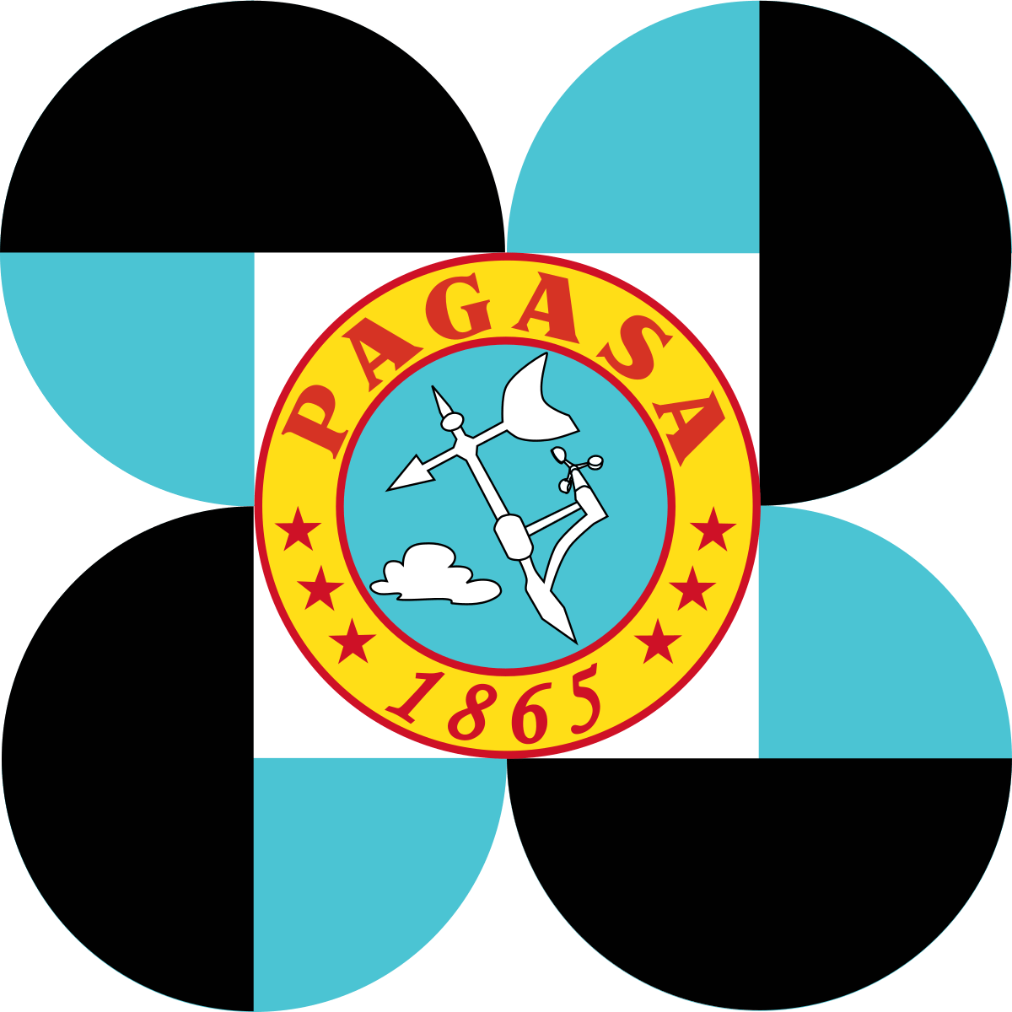
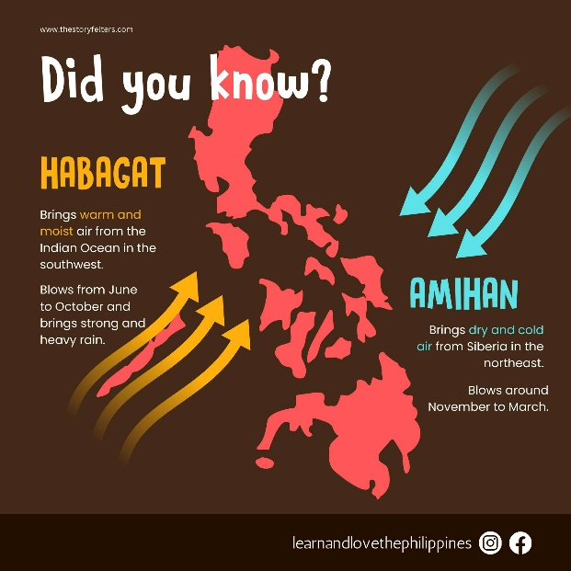

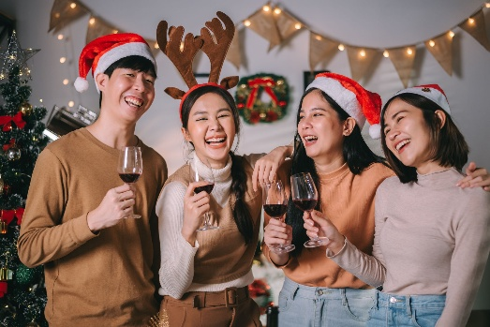
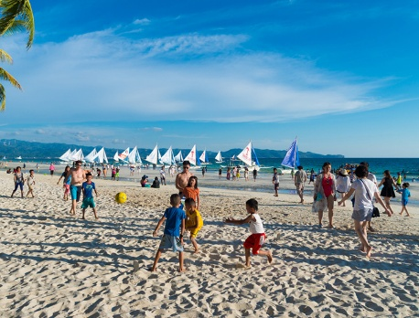
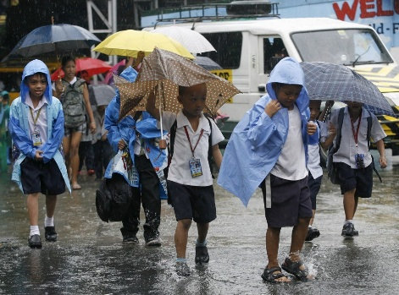

HOT DRY SEASON
AMIHAN
HABAGAT

Term / Concept | Definition
Two Seasons Only | The Philippines has a tropical and maritime climate with only two seasons: Wet and Dry. It does not have winter, spring, or autumn.
Amihan (Northeast Monsoon) | Cool, dry air blowing from Siberia and China; active from December to February; brings cool breezes and Christmas weather.
Habagat (Southwest Monsoon) | Warm, moist air blowing from the equator; active from June to November; brings heavy rains and frequent typhoons.
Hot Dry Season | The local Philippine summer; active from March to May; characterized by peak heat and the highest temperatures when monsoons weaken.
Meteorology | The scientific study of the atmosphere and weather forecasting; led locally by the government agency PAGASA.
PAGASA | Philippine Atmospheric, Geophysical and Astronomical Services Administration
EARTH, SUN, AND MOON RELATIONSHIPS
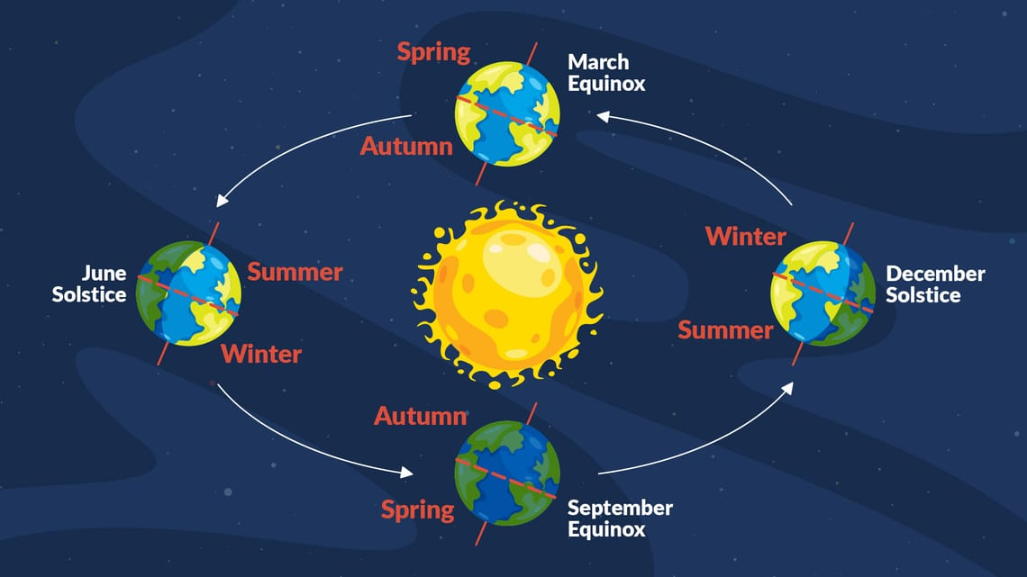

Solstices: Extreme days (longest day or longest night).
Equinoxes: Equal days (12 hours day, 12 hours night everywhere).

NORTHERN HEMISPHERE |  | SOUTHERN HEMISPHERE
Term & Date | Day / Night Effect | Term & Date | Day / Night Effect
Summer Solstice  (June 20 / 21) | Longest day, shortest night | Winter Solstice  (June 20 / 21) | Shortest day, longest night
Winter Solstice  (December 21 / 22) | Shortest day, longest night | Summer Solstice  (December 21 / 22) | Longest day, shortest night
Vernal / Spring Equinox  (March 20 / 21) | Equal day and night | Autumnal / Fall Equinox  (March 20 / 21) | Equal day and night
Autumnal / Fall Equinox  (September 22 / 23) | Equal day and night | Vernal / Spring Equinox  (September 22 / 23) | Equal day and night
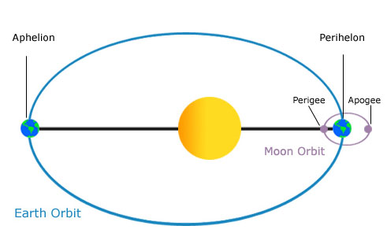
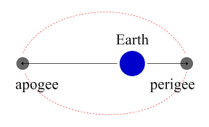

Aphelion / Apogee: Starts with A for Away (Farthest).
Perihelion / Perigee: Starts with P for Proximity / Palapit (Closest).

EARTH & SUN DISTANCES (-HELION) |  | EARTH & MOON DISTANCES (-GEE)
Term & Timeline | Distance Status | Term & Frequency | Distance Status
Aphelion  (Occurs in July) | Earth is farthest from the Sun. | Apogee  (Occurs once a month) | Moon is farthest from the Earth.
Perihelion  (Occurs in January) | Earth is closest to the Sun. | Perigee  (Occurs once a month) | Moon is closest to the Earth.

PHILIPPINE TAGLINES

Place / Province | Tagline / Moniker
Benguet  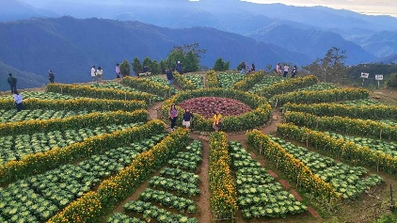  Ano ang tanim sa BENGUET? GULAY  Ano ang meron sa SALAD BOWL? GULAY | Salad Bowl of the Philippines  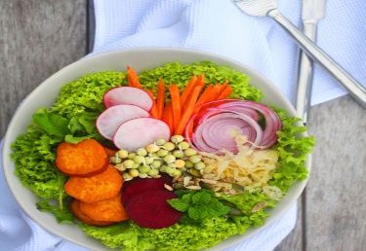
Baguio City  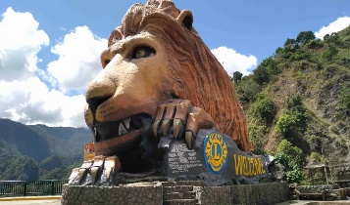 | Summer Capital of the Philippines  kapag mainit (SUMMER) pumunta ka sa malamig (BAGUIO)  
Ilocos Sur  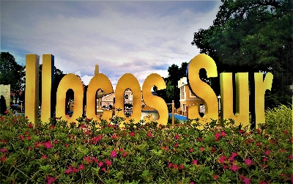  Heritage Houses in VIGAN  VIGAN is in ILOCOS SUR | Heritage Village of the Philippines  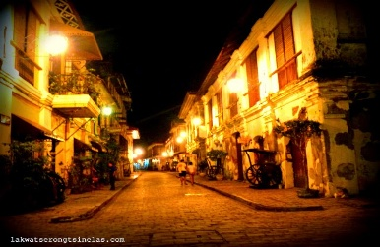
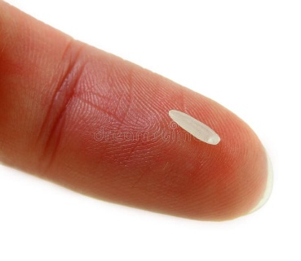  Isabela | Rice Granary of the North  ISAng Butil of RICE  ISABELA: RICE  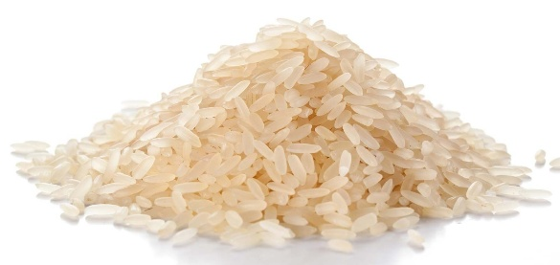
Pampanga  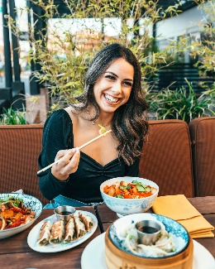  PAMPAgana (CU)main  PAMPANGA: CULINARY | Culinary Center of the Philippines  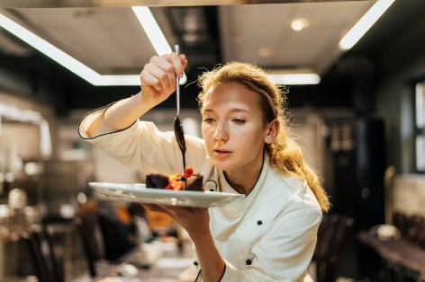
Tarlac    Tarlac: poT  TARLAC: POT | Melting Pot of Central Luzon  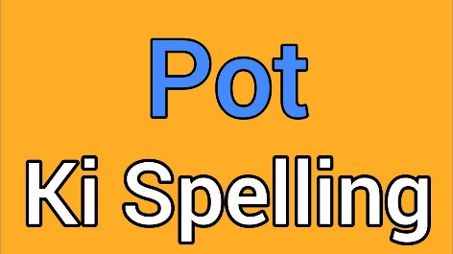
Bulacan    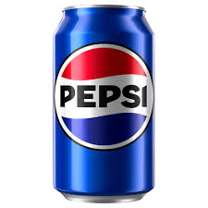  BULA: bubbles  bubbles: HERO! | Land of Heroes  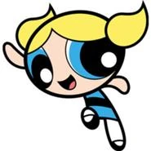  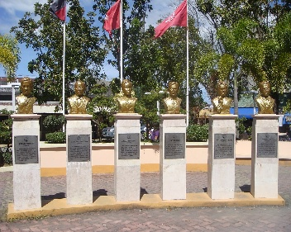
Cavite  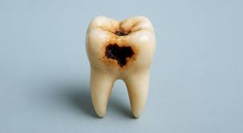 | A Place with a Glorious Past  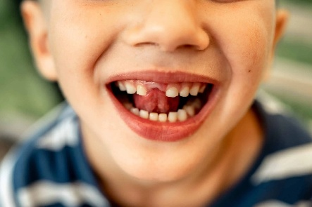  ]  CAVITE: Cavity  Kapag meron kang cavity you need a PASTa
Quezon       | 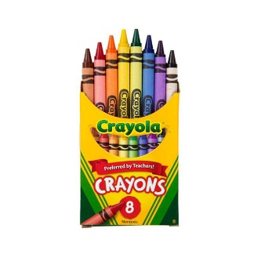  Land of Thousand Colors  Q sounds like C  C: Colors  /K/EZON = /K/OLORS!  
Davao City  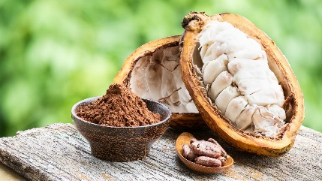  Saan gawa ang CHOCOLATE? Sa CACAO which rhymes with DAVAO! | Chocolate Capital of the Philippines  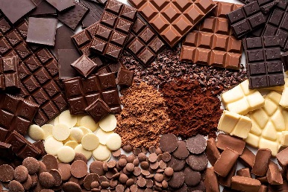
Rizal  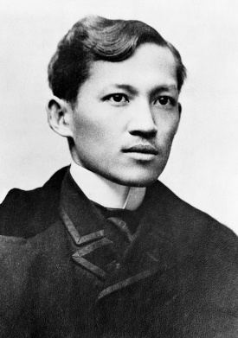 | Cradle of Philippine Art  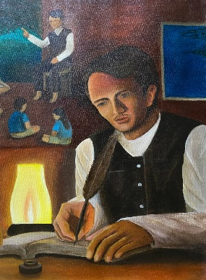  RIZAL niyo marunong din sa ARTS!
Palawan  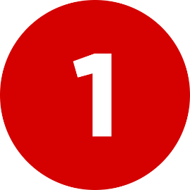  PALAWAN (ONE) laging nasa unahan (FRONTIER)! | The Philippine's Last Frontier  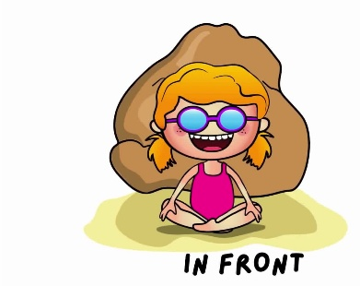
Romblon  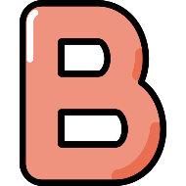   | Marble Capital of the Philippines      Parehong may BL ang romBLon at marble!
Albay  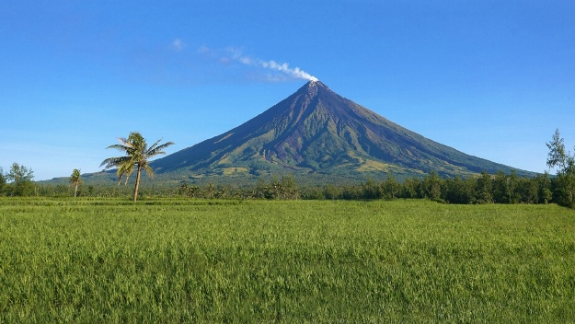  Anong shape ng letter A sa ALBAY? CONE shape gaya ng sa MAYON! |   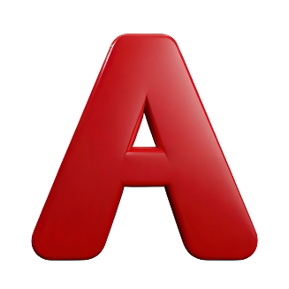  Land of the World's Most Perfect Cone
Sorsogon  I SAW SOME WHALE SHARK!  I saw some (SOrSOgon) WHALESHARK! | 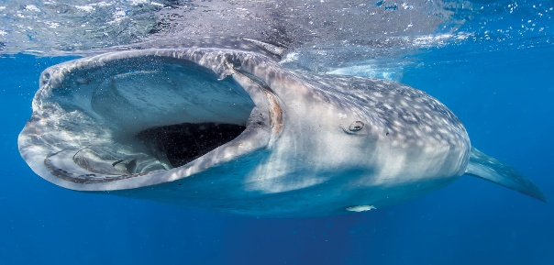  Bicol's Whaleshark Paradise
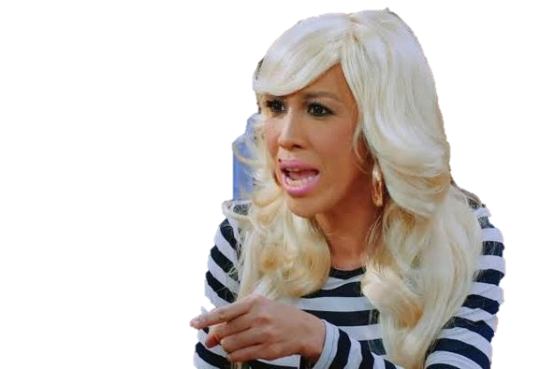  Aklan | 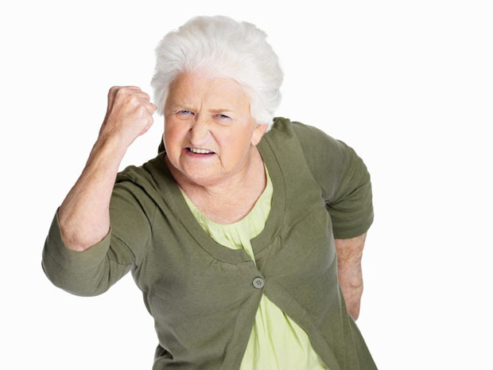  Philippines' Oldest Province  ACCLA vs. TANDA  AKLAN: OLDEST!
Capiz  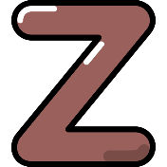  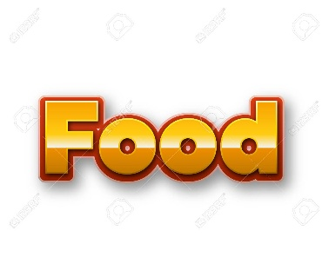 | Seafood Capital of the Philippines  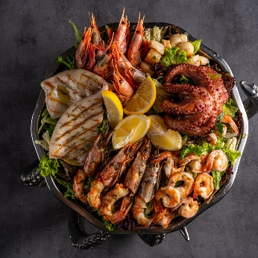  CAPIZZZZZZ  Z food = Sea food!
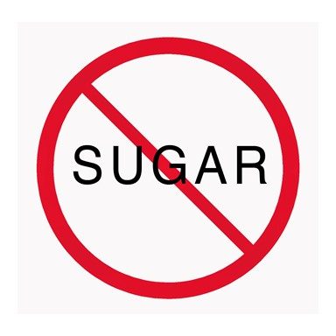  Negros Occidental | 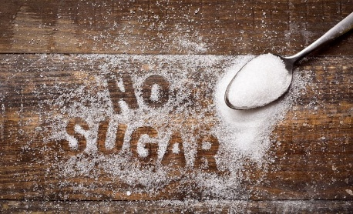  Sugar Bowl of the Philippines  NEGROS OCCIDENTAL: NO  NO + SUGAR  No Sugar!
Cebu City  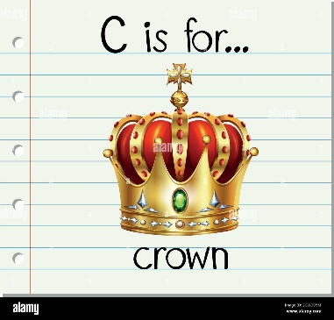  C is for CEBU and CROWN  Sino ba ang may CROWN? Edi QUEEN! | Queen City of the South  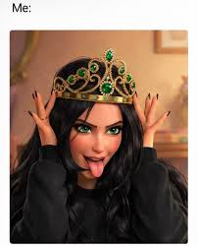
Leyte  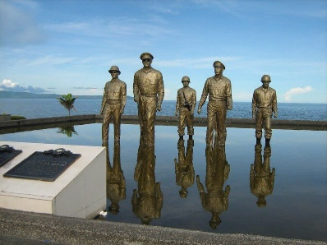 | Land of History  Ikwento mo naman sakin ang HISTORY?  LEYTE (later) na busy pa ko!  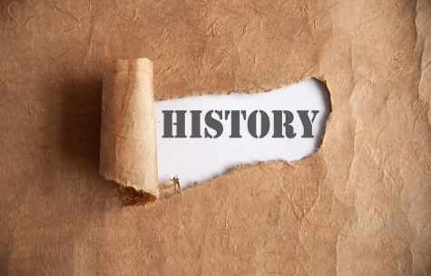
Bukidnon  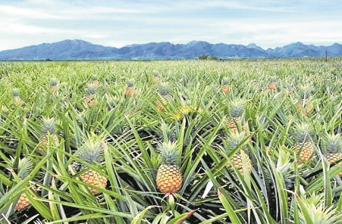 | 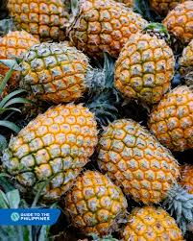  Pineapple Capital of the Philippines  Anong nakatanim sa BUKID niyo? Edi, madaming PINAPPLES!
Dagupan  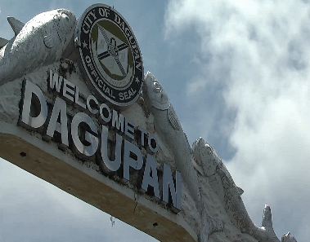  Saan niluluto ang BANGUS? Edi sa frying PAN (DAGUPAN)! | Milkfish/ Bangus Capital of the Philippines  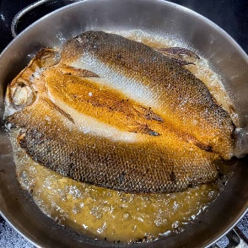
Bacolod  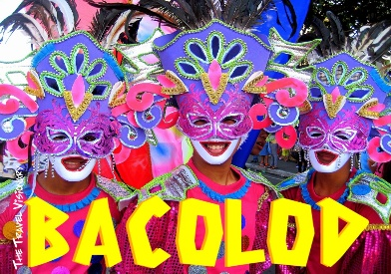 | City of Smile  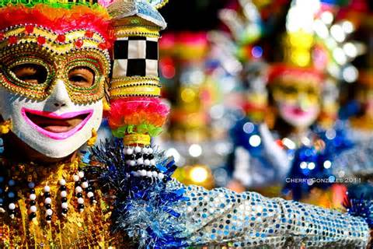  Saan ginaganap ang MASKARA FESTIVAL? Sa BACOLOD. Ano ang itsura ng mga maskara? Naka SMILE!
Zamboanga City  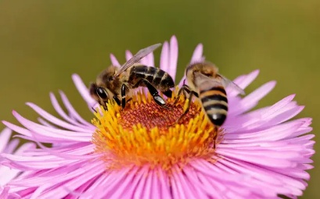 | City of Flowers  Kung saan maraming FLOWERS marami ding BEES. Ano ang tunog ng bees? ZZZZZZZZZ  ZAMBOANGA CITY!  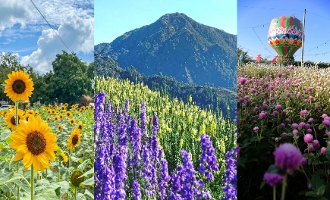
General Santos City  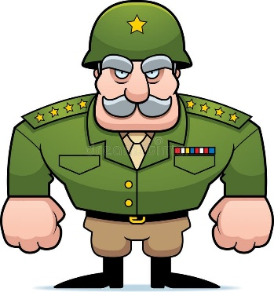 | Tuna Capital of the Philippines    Anong paboritong isda ni GENERAL SANTOS? Edi TUNA!
Guimaras   | Mango Capital of the Philippines  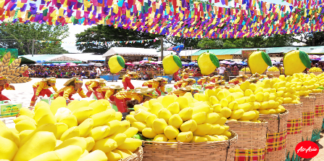  GGGGGGGGGG  Gui Gui Gui: Go Go Go  GUIMARAS: MANGO!  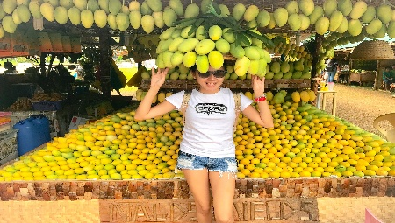
Quezon City  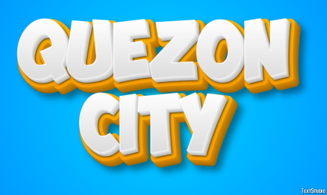 | The City of Stars    Sa QUEZON CITY makikita ang mga STARS/ ARTISTA ng GMA/ ABS-CBN!
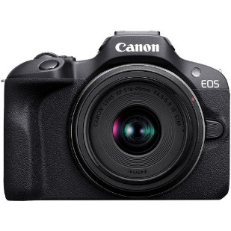  Camiguin | 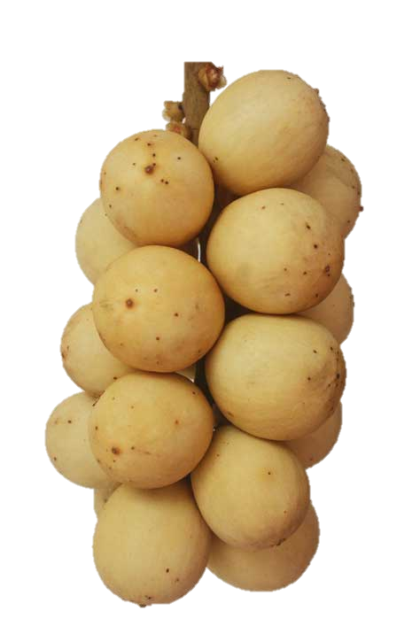  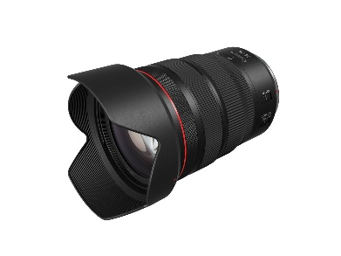  Lanzones Capital of the Philippines  Cam: CAMIGUIN  Lens: LANZONES
Dipolog City  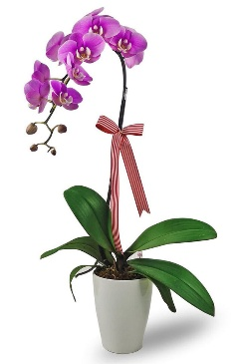    ID vs DI  orchID: DIpolog | Orchid City of the Philippines  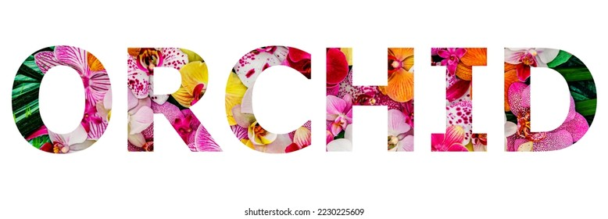
Coron, Palawan  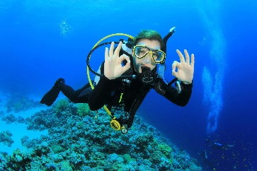  N  C  R | Scuba diving site  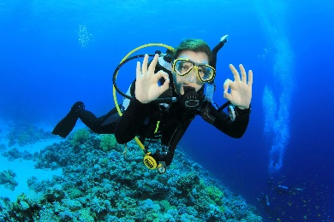  SCUBA diving sign: 2 OK  cOrOn!
Pagadian City  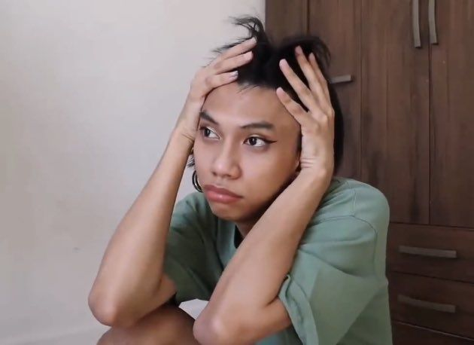  PAGOD YAN? | Little Hongkong  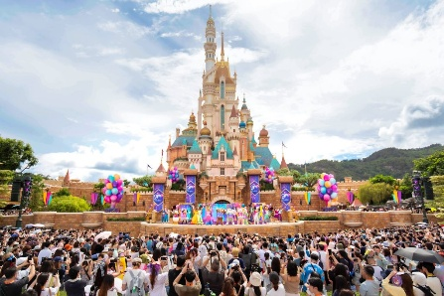  Na pagod yan (PAGADIAN) siya kakalakad sa HONGKONG!
Mindanao  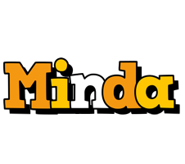 | Land of promise  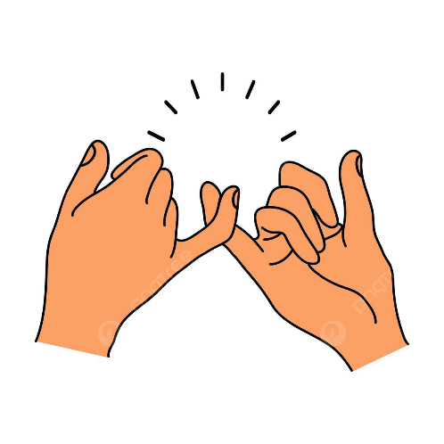  Tutuparin kaya ni MINDA (MINDANAO) ang kanyang PROMISE?
Marinduque  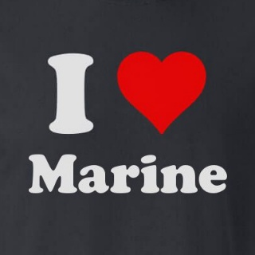  I HEART  MARINe  MARINDUQUE | 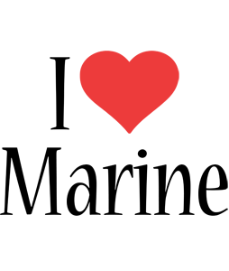  Heart of the Philippines
Cagayan de Oro  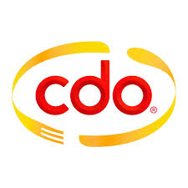 | City of the Golden Friendship  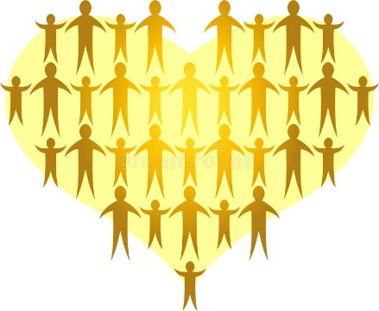  CDO: gOlDen FRIENDSHIP
Makati  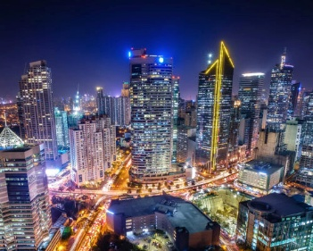 | Manhattan of the Philippines  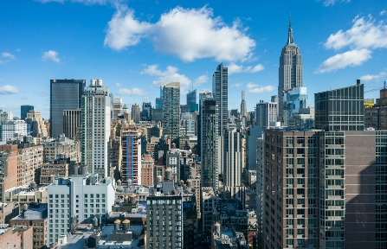  Saan ka makakakita ng MATATAAS na GUSALI gaya sa MANHATTAN? Sa MAKATI
Tawi-Tawi  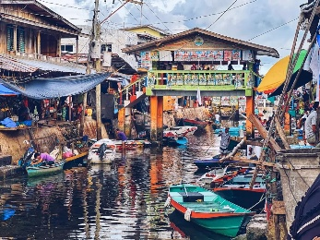 | Venice of the South  Paano ka TATAWID (Taw-Tawi) sa ILOG? Sasakay sa BANGKA gaya sa VENICE  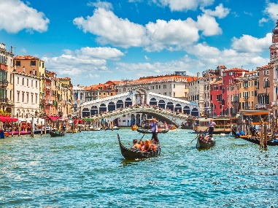
Davao del Norte  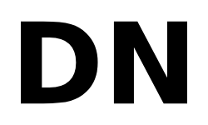  DN: DN  Davao del Norte: DuriaN | Durian and Banana Capital    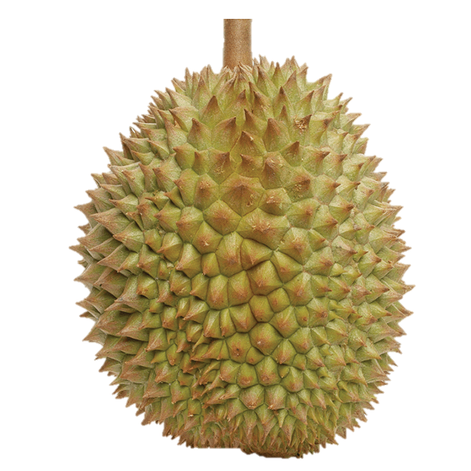
Siquijor  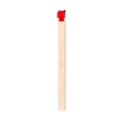    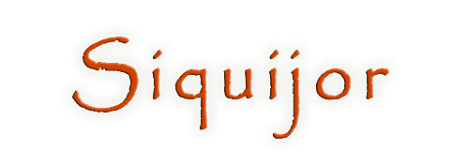  Siquijor: Fire | Island of Fire  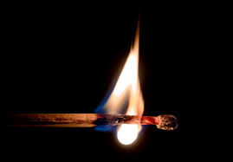
Manila  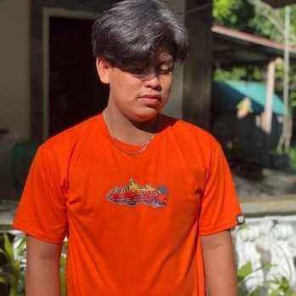  MANila: LOYAL  MAN should be LOYAL | Ever-Loyal City  
TACLOBAN   | Happiest people of the world  HAPPIEST: TACLOBAN  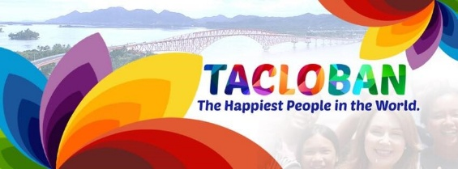

Island Group / Archipelago | Region Code | Official Name
Luzon | - NCR | National Capital Region
 | - CAR | Cordillera Administrative Region
 | - Region I | Ilocos Region
 | - Region II | Cagayan Valley
 | - Region III | Central Luzon
 | - Region IV-A | CALABARZON
 | - MIMAROPA | MIMAROPA Region
 | - Region V | Bicol Region
Visayas | - Region VI | Western Visayas
 | - Region VII | Central Visayas
 | - Region VIII | Eastern Visayas
 | - NIR | Negros Island Region
Mindanao | - Region IX | Zamboanga Peninsula
 | - Region X | Northern Mindanao
 | - Region XI | Davao Region
 | - Region XII | SOCCSKSARGEN
 | - Region XIII | Caraga
 | - BARMM | Bangsamoro Autonomous Region in Muslim Mindanao

- The Philippines is called an archipelago simply because it is made up of a vast cluster or chain of islands
- Islands in the Philippines: 7,641 islands
- There are 18 regions in the Philippines
- New Region is Negros Island Region

What is the longest work of literature in the world?
- Ramayana
- Reg Veda
- Mahabharata
- Upanishad

Epic / Text | Simple Clue Words
Ramayana | - Shorter Indian epic  - tells the story of King Rama and his wife Sita.
Rig Veda | - The oldest of the four sacred Hindu Vedas  - collection of hymns
Mahabharata | - Longest epic/work of literature in the world  - contains the Bhagavad Gita
Upanishad | - Sacred Hindu texts containing philosophical ideas  - spiritual teachings

Who is the famous National Artist from Angono, Rizal?
- Castrillo
- Amorsolo
- San Pedro
- Nick Joaquin

Artist | Simple Clue Words & Masterpiece
Eduardo Castrillo | - Sculptor / brass structures  - People Power Monument
Fernando Amorsolo | - 1st National Artist for Painting  - Rural landscapes and bright light
Lucio San Pedro | - From Angono, Rizal  - Composed Sa Ugoy ng Duyan
Nick Joaquin | - Literature / Hispanic colonial era  - Wrote May Day Eve

WORLD CIVILIZATION

Civilization is where large ideas and tools, as well as human settlements flourished. Where do historians say civilization had first been born?
- China
- Middle East
- Egypt
- Jordan

Cradle / Region | Geographic & Historical Clues | Writing System
China | - Huang He (Yellow River) & Yangtze River  - Oldest continuous civilization | Logograms/ Hanzi  (Oracle Bone Script)
Middle East | - Iraq territory  - Tigris & Euphrates (Twin Rivers)  - Where civilization was first born  - Fertile Crescent / Mesopotamia (Sumerians) | Cuneiform  (Wedge-shaped writing)
Egypt | - Developed along the Nile River (Longest river)  - Known for Pharaohs, mummification, and pyramids | Hieroglyphics  (Sacred carvings on papyrus)
Jordan | - Developed along the Jordan River  - Located in the Levant region of the Middle East  - Famous for the ancient archaeological city of Petra | N/A (Early Semitic/Aramaic scripts)
India | - Developed along the Indus River  - Home to ancient cities like Mohenjo-Daro and Harappa | Indus Script  (Still undeciphered today)
Greece | - Aegean & Mediterranean Seas (maritime focus rather than a major river valley)  - Birthplace of Western Philosophy and Democracy  - city-states like Athens and Sparta | Linear B  Greek Alphabet  (First to use vowels; evolved from Phoenician)
Philippines | - Pasig River, Cagayan River, and coastal areas  - Rich pre-colonial trade network with Asian neighbors | Baybayin  (Ancient indigenous alpha-syllabary script)

Oldest existing religion in Asia.
- Buddhism
- Christianity
- Hinduism
- Islam

DIFFERENT RELIGIONS

Religion | Founder | God / Supreme Being | Holy Book | Core Beliefs & What It Is Known For
Hinduism  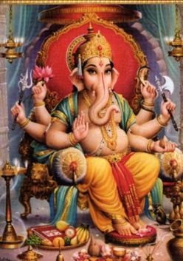 | No single founder | Brahman (Main polytheistic manifestations: Brahma, Vishnu, Shiva) | Vedas / Upanishads / Bhagavad Gita | Oldest existing religion in Asia & the world.  Believes in Karma (actions) and Reincarnation (samsara).
Buddhism  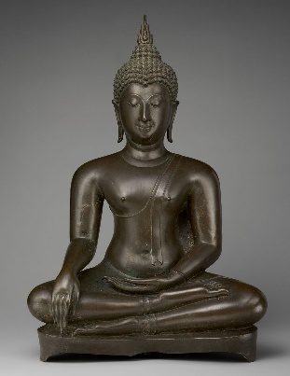 | Siddhartha Gautama (The Buddha) | No creator God (Nontheistic) | Tripitaka (Three Baskets) | Known for the Four Noble Truths and Eightfold Path.  Goal is to reach Nirvana (extinction of suffering).
Christianity  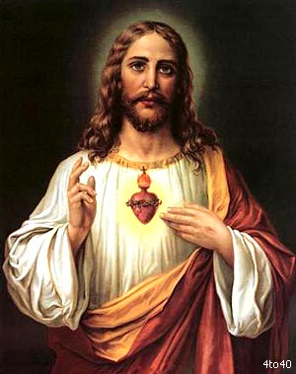 | Jesus Christ | God (The Holy Trinity: Father, Son, Holy Spirit) | Holy Bible | Largest religion in the world.  Central belief in the Resurrection of Jesus and salvation by faith.
Islam  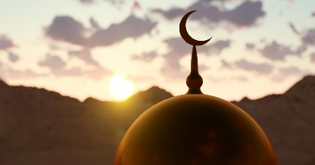 | Prophet Muhammad | Allah | Quran (Koran) | Followers are called Muslims.  Governed by the Five Pillars of Islam (Shahada, Salat, Zakat, Sawm, Hajj).
Judaism  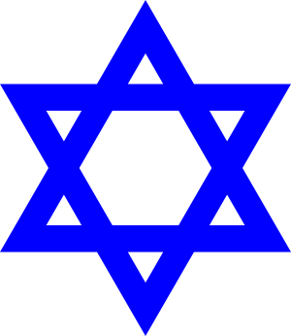 | Abraham | Yahweh | Torah (First 5 books of the Hebrew Bible) | Oldest monotheistic religion; covenants made with Abraham and Moses.  Follows the Ten Commandments.
Shintoism  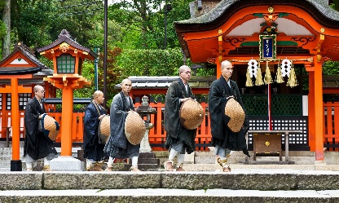 | No single founder | Kami (Nature spirits / Ancestors) | Kojiki / Nihon Shoki | Indigenous religion of Japan.  Focuses on animism, ritual purity, and deep reverence for nature.
Taoism  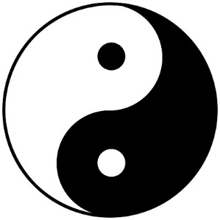 | Lao Tzu | The Tao (The Way - a universal force, not a person) | Tao Te Ching | Ancient Chinese philosophy/religion.  Known for the concept of Yin and Yang (balance) and Wu Wei (effortless action).

FORMER NAMES

Former Name | Current Country Name
Kampuchea | Cambodia
Mesopotamia | Iraq
Burma | Myanmar
Persia | Iran
Ceylon | Sri Lanka
Siam | Thailand
Formosa | Taiwan

SMALLEST & LARGEST

Category / Superlative | Answer / Feature
Smallest Ocean | Arctic Ocean
Smallest Country | Vatican
Largest Ocean | Pacific Ocean
Largest Island | Greenland
Largest Bay | Bay of Bengal
Largest Country in Asia (Overall) | China
Largest Country in the World | Russia
Largest Country in South Asia | India
Largest Country in East Asia | China
Largest Country in North Asia | Russia (Siberian region)
Largest Country in West Asia | Saudi Arabia
Largest Country in Central Asia | Kazakhstan
Largest Archipelago (Region) | Malay Archipelago
Largest Archipelagic Country | Indonesia

ERAS OF PHILIPPINE HISTORY (PSA CJR NP)

Historical Era & Mnemonic | Keywords
P – Pre-Spanish | Primitive survival era
S – Spanish Period | religious education
A – American Period | public education
C – Commonwealth Era | social justice
J – Japanese Occupation | love for work / dignity of labor.
R – Third Republic | Education for All (EFA)
N – New Society | high number of professionals
P – Present Times | Enhanced Basic Education (K-12 Program).

HAIKU VS. TANAKA

HAIKU | TANKA
Total Syllables  17 syllables | Total Syllables  31 syllables
Structure  3 lines (5 - 7 - 5 pattern) | Structure  5 lines (5 - 7 - 5 - 7 - 7 pattern)
Main Theme  Nature and seasons (Kigo) | Main Theme  Emotions, love, and relationships
Main Proponent  Matsuo Basho (Grand Master/Father of Haiku) | Main Proponent  Ono no Komachi (Legendary classical master)

JAPANESE PERIOD

Concept / Group | Key Role / Event | Simple Study Breakdown
Educational Focus | Vocational Training | Stressed Tech-Voc skills alongside a love for work and the dignity of labor.
Little Boy (Aug 6, 1945) | Hiroshima Atomic Bomb | The specific codename of the nuclear weapon dropped by the US on Hiroshima.
HUKBALAHAP | Anti-Japanese Guerillas | Short for Hukbong Bayan Laban sa Hapon; local fighters against the occupation.
MAKAPILI | Filipino Traitors | Pro-Japanese local sympatherizers who acted as informants against fellow Filipinos.
KEMPEITAI | Military Police Corps | The brutal Japanese military police unit notorious for enforcing strict rules and torture.

Which is used by government from 1971 to 2003 to remain in power.
- Commercials
- Media
- industries
- Cooperatives

- Oldest newspaper: Manila Bulletin

FILIPINO WRITERS, PEN NAMES, AND LITERARY TERMS

Term / Title / Pen Name | Correct Answer / Author | Clues
Balagtas | Francisco Baltazar | Wrote the epic poem Florante at Laura.
Kuntil -butil | Florentino Collantes | Famous master of the Duplo and early Balagtasan.
Huseng Batute | Jose Corazon de Jesus | The legendary King of Balagtasan.
Huseng Sisiw | Jose dela Cruz | The famous literary mentor of Francisco Balagtas.
G. Solon | Epifanio delos Santos | The brilliant scholar after whom EDSA was named.
Lola Baysang | Severino Reyes | Father of Tagalog Plays (Sarswela); wrote Mga Kuwento ni Lola Basyang.
Amante Ernani / Herminia dela Riva / Julio Abril | Amado Hernandez | Legendary writer known as the Makata ng Manggagawa.
Quijano de Manila | Nick Joaquin | Celebrated National Artist for Literature.
Doveglion | Jose Garcia Villa | Renowned modern poet known as the "Comma Poet."
Memoria Photographica | JoMaPa (Jose Maria Panganiban) | Bicolano propagandist known for his extraordinary photographic memory.
Child of Sorrow | Zoilo Galang | The very first Filipino novel written in English (A Child of Sorrow).
Urbana at Felisa | Modesto de Castro | Classic epistolary prose establishing traditional Filipino manners.
Aloha | Deogracias Rosario | A landmark classic romantic short story set in Hawaii.
Father of Tagalog Classics | Modesto de Castro | Title earned for his refined, classical Tagalog prose style.
Sampagitang walang bango | Iñigo Ed. Regalado | Famous satirical Tagalog novel detailing societal corruption.
Tagalog Joan of Arc | Teresa Magbanua | The legendary woman general and warrior of the Visayas.
First and longest running komiks | Liwayway / Kenkoy | Celebrated magazine that birthed the early Filipino comic strip industry.
First filipino Publisher | Tomas Pinpin | Known historically as the Prince of Filipino Printers.
Ama ng Maikling Kwentong Tagalog | Deogracias Rosario | Title awarded for standardizing the Tagalog short story structure.
First Palanca Award for Short Story | Genoveva Edroza-Matute | Won the inaugural award for her absolute masterpiece "Kuwento ni Mabuti".
First Palanca Award for Play | Dionesio Salazar | Highly decorated and legendary multi-awarded Filipino playwright.
First Filipino Diplomat | Felipe Agoncillo | Outstanding lawyer who foreign-represented the First Philippine Republic.
Ang madamdaming mananalaysay ni Nakpil | Teodoro Agoncillo | Renowned nationalist historian noted for writing history from a Filipino lens.
"Ang pag-ibig ay hindi pag-ibig..." | William Shakespeare | Iconic translated line opening his famous Sonnet 116.
First Filipino Cannon-maker | Panday Pira | Muslim blacksmith from Pampanga who forged heavy artillery for Rajah Sulayman.
Sa Pula sa Puti | Francisco Soc Rodrigo | Highly celebrated satirical play mocking the local cockfighting obsession.
Bayan ko naglapat ng titik | Jose Corazon de Jesus | Penned the brilliant patriotic lyrics for the timeless resistance song Bayan Ko.
Ama ng Lingwestikang Pilipino | Cecilio Lopez | The pioneering academic who scientifically structured indigenous Philippine language study.

GENERATIONS

Generation & Years | Label | Simple Clue Words
Lost Generation  (1883–1900) | None | World War I, disillusioned
Greatest Generation  (1901–1927) | None | World War II, patriotic, sacrifice
Silent Generation  (1928–1945) | Formal | Traditional, conformist, respects authority (wala masyadong nag-anak kasi the world is chaotic)
Baby Boomers  (1946–1964) | Structured | Workaholics, corporate loyalty, hierarchy (nag boom ang numbers ng baby kasi tapos na ang war kaya humawa na sila ng baby)
Generation X  (1965–1980) | Participative | Independent, self-reliant, work-life balance
Millennials  (1981–1996) | Interactive | Tech-savvy, collaborative, digital rise
Generation Z  (1997–2012) | Multi-modal | Digital natives, multitasking, visual learners
Gen Alpha  (2013–2024) | Virtual | AI integrated, tablets, virtual learning
Gen Beta  (2025–2039) | AI-Native | Zero pre-AI memory, born to Gen Z/Millennials

GLOBAL TREATIES AND ENVIRONMENTAL LAWS

Term / Law | Simple Clue Words
Geneva Convention | To cure and protect wounded soldiers / rules of war
Kyoto Protocol | Mitigating global warming / reducing greenhouse gases
Philippine Clean Air Act of 1999 | Ban the use of incinerators / Republic Act 8749

An area of land, sea, or space, belonging or connected to a particular country which is subject of sovereignty rights and interests.
- Archipelago
- Territory
- Sovereignty
- Government

THE FOUR ELEMENTS OF A STATE (PSGTE)

Element | Simple Definition
Population | The people or citizens who live inside the country.
Sovereignty | The supreme power or freedom of the state to rule itself without outside control.
Government | The agency or organization that creates and enforces laws.
Territory | The definite land, water, and air space occupied by the state.

INHERENT POWERS OF THE STATE

Power | Clue Words
Police Power | Promotes general welfare, public health, safety, and public morals.
Power Of Expropriation | Also known as Eminent Domain; taking private property for public use with just compensation (fair market value).
Taxation | A charge of burden on persons or property to raise revenue for government expenses.

TYPES OF TAX

Tax Type | Clue Words
Income Tax | Graduated tax table, Salary deduction, Yearly earnings, Practicing professionals
Community Tax | Cedula, Poll tax, Cannot be jailed for non-payment
Sin Tax | Tobacco, Alcohol, Health financing, Regulatory tax
Ad Valorem Tax | According to value, Fixed percentage, Market worth
Import Tax | Tariff, Importation, Customs duties, International trade
Inheritance Tax | Death of owner, Transfer to heirs, Estate tax, paid by heirs of the inheritance
Property Tax | Broad asset tax, Ownership tax, Wealth tax
Real Estate Tax | Properties, Amilyar, Land and buildings, Annual local tax
Corporate Tax | Tax from businesses
Capital Gain Tax | Paid by the seller

- The present form of government of the Philippines is Democratic, Republican, and Presidential.

FORMS OF GOVERNMENT

Government Type | Clue Words
Monarchy | King or Queen, Royal family, Hereditary rule
Anarchy | No government, Lawlessness, Chaos, No ruler  Constitutional / absolute
Aristocracy | Elite class, Wealthy families, Privilege, Noble birth
Oligarchy | Few powerful people, Small group, Self-interest
Democracy | Power to the people, Voting, Elections, Majority rule
Parliamentary | Prime Minister, Cabinet, Fusion of executive and legislative
Federalism | Divided powers, Central and local states, Autonomy
Necrocracy | Dead leader, Eternal ruler, North Korea
Meritocracy | Ability and talent, Earned power, Skills, Achievement
Communism | Classless society, State ownership, No private property
Modern Capitalism | Free market, Private ownership, Profit-driven, Competition
Primitive Communism | Hunter-gatherer, Shared resources, No private ownership, Tribal  Karl Marx Early Mode of Life
Revolutionary Government | Temporary rule, Overthrow, Dictatorial power, Aguinaldo, Cory Aquino

Power of the state which levies or imposes a financial obligation on its citizens or residents.
  - Police Power
  - Eminent Power
  - Income Tax
  - Taxation

TYPES OF TAX SYSTEM
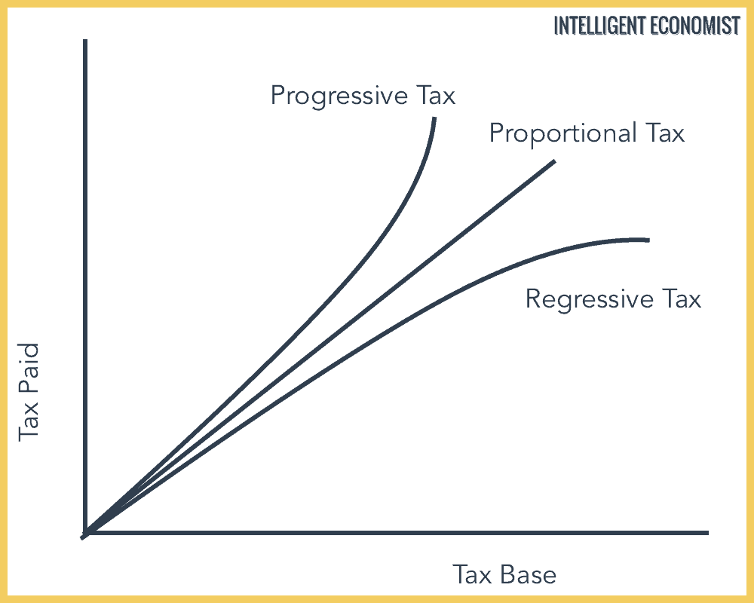

- Progressive (Curving Up): As a person's income increases, their tax rate also goes up. The graph curves upward because high earners are placed in higher tax brackets.

- Proportional (Flat Line): The tax rate stays exactly the same for everyone, whether income is low, middle, or high. It is a straight, flat horizontal line.

- Regressive (Curving Down): As a person's income increases, the tax takes a smaller percentage of their total income. It curves downward because it hurts low-income earners the most.

Tax System | Clue Words
Progressive | Higher income pays higher tax rate, Rich pay more, Philippine Income Tax
Proportional | Same tax rate for all, Flat tax, Equal percentage regardless of wealth
Regressive | Higher income pays lower effective tax rate, Burdens the poor, VAT

THREE BRANCHES OF GOVERNMENT

Branch of Government | Main Function | Clue Words
Legislative | Makes laws | Congress, Senate, House of Representatives, Power of the purse
Executive | Enforces laws | President, Cabinet, Veto power, Commander-in-Chief
Judicial | Interprets laws | Supreme Court, Lower courts, Judicial review, Settlement of legal controversies

SYSTEM OF CHECKS AND BALANCES

How They Check Each Other | Specific Action / Mechanism | Clue Words
Executive checks Legislative | The President rejects a law passed by Congress. | Presidential Veto
Legislative checks Executive | Congress overrides a veto or approves appointments. | Two-thirds override, Commission on Appointments
Judicial checks Both | The Supreme Court declares a law or action invalid. | Unconstitutional, Judicial Review
Legislative checks Judicial | Congress changes court jurisdictions or removes judges. | Impeachment power, Amendments

Who has the power to declare the existence of War?
- Senate
- House of Representatives
- President
- Congress

QUALIFICATIONS OF PHILIPPINE CONSTITUTIONAL POSITIONS

Position | Citizenship | Minimum Age | Literacy / Status | Minimum Residency | Term of Office
President | Natural-born | At least 40 years old | Able to read & write, Registered voter | 10 years in the Philippines | 6 years (Strictly no re-election)
Vice President | Natural-born | At least 40 years old | Able to read & write, Registered voter | 10 years in the Philippines | 6 years (Maximum of 2 consecutive terms)
Senator | Natural-born | At least 35 years old | Able to read & write, Registered voter | 2 years in the Philippines | 6 years (Maximum of 2 consecutive terms)
District Representative | Natural-born | At least 25 years old | Able to read & write, Registered voter | 1 year in the district | 3 years (Maximum of 3 consecutive terms)
Supreme Court Justice | Natural-born | At least 40 years old | Member of the Bar, Proven competence | 15 years as a judge/lawyer | Good behavior until age 70

NUMBER OF SEATS/POSITIONS PER OFFICE

Position | Total Number of Seats / People | Context
President | 1 person | Executive Head of State and Government
Vice President | 1 person | Second-highest official; first in line of succession
Senator | 24 people | All are elected nationwide (at-large)
District Representative | 254 people | Elected by specific local legislative districts
Supreme Court Justice | 15 people | 1 Chief Justice and 14 Associate Justices

- While there are 254 District Representatives, the complete House of Representatives also includes 64 Party-List Representatives, bringing the grand total of the lower chamber to 318 members. Together with the 24 Senators, the entire Congress consists of 342 lawmakers.

QUALIFICATIONS OF A VOTER IN THE PHILIPPINES

Voter Status / Requirement | Constitutional Feature | Clue Words
Citizenship | Must be a citizen of the Philippines | Filipino citizen, Dual citizens under RA 9225
Minimum Age | At least 18 years old on election day | 18 years of age
National Residency | Resided in the Philippines for at least 1 year | 1 year residency
Local Residency | Resided in the voting district for at least 6 months | 6 months residency
Disqualifications | Anyone declared insane, or convicted of a crime involving rebellion, sedition, or a penalty of 1+ years | Sentenced by final judgment, Mental incompetence
Substantive Barriers | No literacy, property, or educational tax requirements can be used to stop someone from voting | No literacy requirement, No property requirement

CORE POLITICAL RIGHTS AND CONCEPTS

Term | Simple Definition | Clue Words
Suffrage | The right and obligation of a citizen to vote in elections. | Right to vote, Plebiscite, Article V, Popular sovereignty
Disenfranchise | To legally deprive or take away a person's right to vote. | Disqualified, Criminal conviction, Deprived of suffrage
Political Right | Rights that allow citizens to participate in government operations. | Right to vote, Right to run for office, Petition for redress

The principle of checks and balances is intended to maintain balance among executive, legislative and judicial departments of the government. Which one is a check on the executive department by the judiciary?
- Determining the salaries of the President and Vice President
- Declaring a legislative measure unconstitutional
- Declaring an act of the president unconstitutional
- Impeaching the President

It is the guarantee given by the Constitution to certain units of the government.
- Gemeinschaft
- Gesellschaft
- Fiscal Autonomy
- Just Compensation

Concept | Simple Definition
Fiscal Autonomy | Financial independence to spend budgets freely.
Gemeinschaft | A close-knit community based on personal bonds.
Gesellschaft | A society based on impersonal and civil relations.
Just Compensation | Fair payment given to owners for private property.

KINDS OF WRIT

Legal Writ | Clue Words
Writ of Amparo | Right to life, liberty, and security, Extralegal killings
Writ of Habeas Corpus | Show me the body, Produce the body, Illegal detention
Writ of Habeas Data | Right to information, Privacy, Destroying false data
Writ of Kalikasan | Clean and healthy environment, Nature protection

CONSTITUTION

Term | Clue Words
Constitution | Fundamental law of the land, Supreme law, Highest law
1987 Constitution Formation | Constitutional Commission, Appointed by Cory Aquino, Plebiscite

CLASSES OF RIGHTS

Class of Right | Clue Words
Natural Rights | Given by God, Inherent, Universal, Right to live, Right to love
Constitutional Rights | Written in the supreme law, Protected by the Constitution
Civil Rights | Happiness, Private life, Marriage, Properties, Peace, Liberty
Political Rights | Government participation, Voting, Suffrage, Running for public office
Bill of Rights | Article III, Shield against state abuse, Protection of citizens
Statutory Rights | Created by law-making bodies, Congress acts, Passable by legislation
Inalienable Rights | Cannot be taken away, Cannot be sold, Cannot be surrendered
Alienable Rights | Can be transferred, Can be given away, Private property ownership

- Constitutional vs. Statutory: Constitutional rights cannot be changed easily by ordinary congressmen. Statutory rights can be updated, modified, or completely removed by a new law passed in Congress (e.g., changing the legal retirement age).

- Inalienable vs. Alienable: Your right to life is inalienable—you cannot legally sign it away or sell yourself into slavery. However, your right to sell a piece of land or transfer a car title is an alienable property right.

CITIZENSHIP MODES

Citizenship Term | Clue Words
Natural-Born Citizen | Citizenship from birth, No legal action needed to acquire
Jus Sanguinis | Right of blood, By bloodline, Filipino parents, Philippine system
Jus Soli | Right of soil, By place of birth, Born in America, Foreign territory
Naturalized Citizen | Legal process, Adopted by a country, Oath of allegiance, Court act
- Precinct vs. Barangay: In general governance, the Barangay is the lowest geopolitical unit of government in the Philippines. However, in the context of elections and voting logistics, the Election Precinct is the smallest administrative unit used to group voters.

- Disenfranchisement Causes: A person becomes disenfranchised primarily through legal disqualifications, such as being sentenced by final judgment to prison for a period of not less than one year.

DEMOCRATIC PROCESSES AND ELECTION

Term / Process | Clue Words
Election | Process to choose officials, Popular choice
Regular Elections | Second Monday of May, Scheduled synchronized voting
Plebiscite | Vote for or against constitutional change, Approve amendments
Referendum | Approve or reject a law, Law validation by the electorate
Initiative | Citizens directly propose and enact law, People’s initiative
Recall | Removal due to loss of confidence, Remove public officer early

IMPEACHABLE OFFICIALS

Impeachable Official | Clue Words
President and Vice President | Executive branch heads, Highest officials, Impeachment trial
Supreme Court Members | Chief Justice, Associate Justices, Judicial branch heads
Constitutional Commission Members | COMELEC, COA, CSC, Independent body chairs
The Ombudsman | Tanodbayan, Public protector, Graft and corruption investigator

Called as the Tanod-bayan
- Court of appeals
- Ombudsman
- Sandiganbayan
- Supreme court

GROUNDS FOR IMPEACHMENT

Grounds for Impeachment | Clue Words
Culpable violation of the Constitution | Intentional violation, Breaking supreme law deliberately
Treason | Levying war, Adhering to enemies, Giving aid and comfort
Bribery | Accepting gifts, Receiving money to influence official duty
Graft and Corruption | Public office for private gain, Illegal accumulation of wealth
Betrayal of public trust | Loss of confidence, Serious abuse of power, Cronyism
Other high crimes | Gross offenses, Severe crimes against state security

- Economics is a social science that studies how people allocate scarce resources for production, distribution, and consumption.

FACTORS OF PRODUCTION

Factor of Production | Simple Definition | Clue Words
Capital | Man-made resources used to create other goods and services. | Machinery, Tools, Factories, Equipment
Entrepreneur | The person who combines all factors to create a business and takes risks. | Risk-taker, Business innovator, Manager
Land | All natural resources provided by nature used in production. | Soil, Water, Minerals, Forests, Raw materials
Labor | Human effort, both physical and mental, applied to produce goods. | Workers, Human resource, Salaries, Wages

LAWS IN ECONOMICS

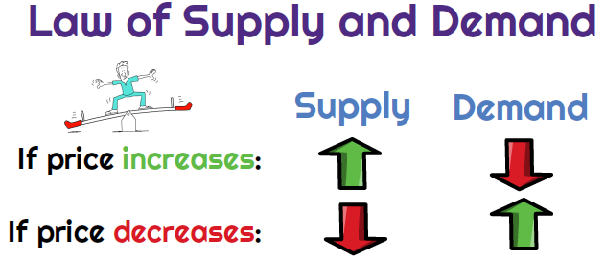

Term / Law | Clue Words
Demand | Consumer willingness and financial ability to buy goods at various prices.
Law of Demand | Inverse relationship between price and demand. Price goes up, demand goes down.
Supply | Producer willingness and ability to sell goods at various prices.
Law of Supply | Direct relationship between price and supply. Price goes up, supply goes up.
Ceteris Paribus | All other variables or factors remain constant and unchanged.
Market Equilibrium | The balancing point where quantity demanded exactly equals quantity supplied.

ELASTICITY OF DEMAND

Term / Concept | Clue Words
Normal Goods | Goods you buy more of when your income increases. Direct relationship. Brand new clothes.
Inferior Goods | Goods you buy less of when your income increases. Inverse relationship. Instant noodles, secondhand items.
Elastic Demands | Big change in demand when price changes. Non-essential items, Luxury goods, Soft drinks.
Inelastic Demands | Small or no change in demand when price changes. Essential items, Medicine, Water, Rice.

MACROECONOMIC INDICATORS AND MARKET

Term / Concept | Clue Words
Appreciation | Increase in value of a currency or asset. Stronger currency, Value increase.
Depreciation | Decrease in value of a currency or asset. Weaker currency, Value decrease.
Surplus | Market condition where supply is greater than demand. Excess products, Leftovers.
Shortage | Market condition where demand is greater than supply. Scarcity, Not enough goods.
GNP | Total value of goods produced by a country's citizens worldwide. Gross National Product, Nationality-based.
GDP | Total value of goods produced within a country's geographic borders. Gross Domestic Product, Location-based.
Inflation | A sustained increase in the general price level of goods. Prices rising, Lower purchasing power.
Deflation | A sustained decrease in the general price level of goods. Prices dropping, Negative inflation.
Hyperinflation | Extremely rapid, out-of-control price increases. Currency becomes worthless, Economic collapse.

IMPORTANT GLOBAL, CULTURAL, AND ECONOMIC

Term / Concept | Clue Words
Ceteris Paribus | Latin term meaning all other variables or factors remain unchanged. All variables kept constant.
Rio de Janeiro Convention | Global agreement focusing on Education for Sustainable Development. Convention about ESD, Environmental protection.
NCCA | National Commission for Culture and the Arts. Government body that nurtures Philippine arts and cultural heritage.
Modern Capitalism | An economic system driven by private profit, free markets, and individual innovation. Entrepreneurship, Free enterprise.
Mercantilism | An economic theory focusing on accumulating gold and wealth through a positive trade balance. Economic policy in the 16th century, Bullionism.

LEGAL AND SOCIAL JUSTICE

Term / Concept | Clue Words
Tax-Exempt Pensions | Retired government employees, Receiving pension only, Tax exemption
Party-List Restriction | Religious sectors, Not allowed, Lower chamber exclusion
RA 9994 | ESCA, Expanded Senior Citizens Act, 20% discount, VAT exemption
Parens Patriae | Father of the country, Paternal role, Protective state, Citizen welfare
Social Justice | Preferential attention, Those who have less in life, Social equity

